4.12:
#include <iostream>
using namespace std;

int main() {
int n = 6;
// Pattern (a)
for (int i = 1; i <= n; ++i) {
for (int j = 1; j <= i; ++j) cout << '*';
cout << endl;
}
cout << endl;

// Pattern (b)
for (int i = n; i >= 1; --i) {
for (int j = 1; j <= i; ++j) cout << '*';
cout << endl;
}
cout << endl;

// Pattern (c)
for (int i = 1; i <= n; ++i) {
for (int s = 0; s < n - i; ++s) cout << ' ';
for (int j = 0; j < i; ++j) cout << '*';
cout << endl;
}
cout << endl;

// Pattern (d)
for (int i = n; i >= 1; --i) {
for (int s = 0; s < n - i; ++s) cout << ' ';
for (int j = 0; j < i; ++j) cout << '*';
cout << endl;
}
cout << endl;

return 0;
}
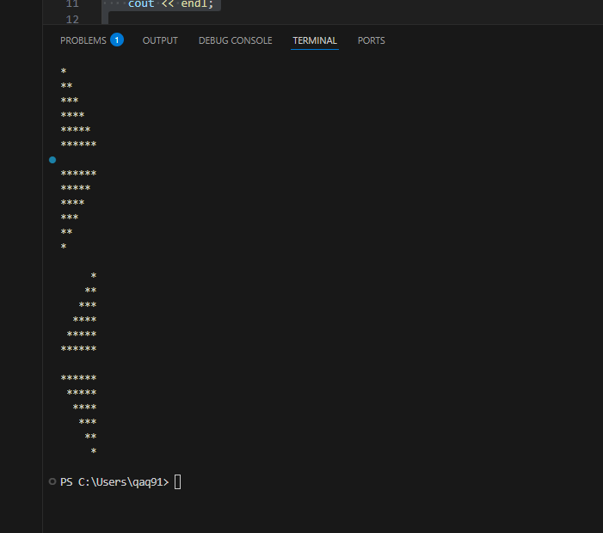
4.14:
#include <iostream>
using namespace std;

int main() {
const double price1 = 2.98, price2 = 4.50, price3 = 9.98, price4 = 4.49, price5 = 6.87;
int product;
long long totalQuantity = 0;
double totalSales = 0.0;

cout << "Enter product number (1-5) and quantity. Enter -1 to finish.\n";
while (true) {
cout << "Product (-1 to end): ";
cin >> product;
if (product == -1) break;
if (product < 1 || product > 5) {
cout << "Invalid product number, try again.\n";
continue;
}
int qty;
cout << "Quantity: ";
cin >> qty;
double price = 0.0;
switch (product) {
case 1: price = price1; break;
case 2: price = price2; break;
case 3: price = price3; break;
case 4: price = price4; break;
case 5: price = price5; break;
}
totalQuantity += qty;
totalSales += price * qty;
}

cout.setf(ios::fixed);
cout.precision(2);
cout << "Total items sold: " << totalQuantity << "\n";
cout << "Total retail value: $" << totalSales << "\n";
return 0;
}
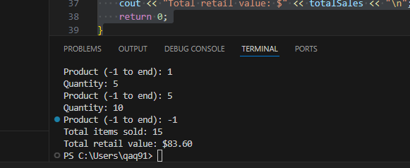

4.20:
#include <iostream>
#include <cmath>
using namespace std;

int main() {
const int LIMIT = 500;
for (int a = 1; a <= LIMIT; ++a) {
for (int b = a; b <= LIMIT; ++b) { // b>=a 避免重複與交換
int c2 = a*a + b*b;
int c = (int)round(sqrt((double)c2));
if (c <= LIMIT && c*c == c2) {
cout << a << "\t" << b << "\t" << c << "\n";
}
}
}
return 0;
}